UNIT 3

- Explain the key components of Spark MLlib and discuss how it supports large-scale machine learning tasks. Provide examples of its applications.
Spark MLlib is a scalable machine learning library that's part of the Apache Spark ecosystem. It's designed specifically for large-scale distributed machine learning tasks, offering significant performance advantages over traditional single-machine learning frameworks.
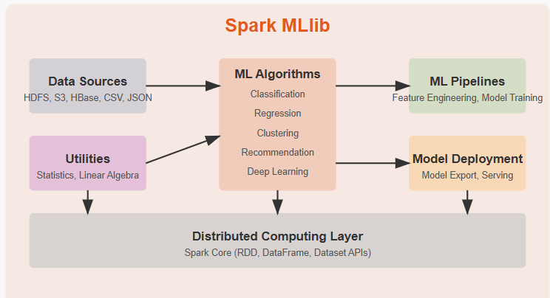

1. Data Handling and Preprocessing
MLlib provides tools for:
- Feature extraction: Converting raw data into features suitable for ML algorithms
- Feature transformation: Normalizing, scaling, and encoding features
- Feature selection: Identifying the most predictive features
- Dimensionality reduction: Techniques like PCA to reduce feature space
These components operate on Spark's distributed data structures (RDDs, DataFrames, and Datasets), enabling preprocessing of massive datasets across clusters.

2. Machine Learning Algorithms
MLlib offers a comprehensive set of algorithms for various tasks:
- Classification: Logistic regression, decision trees, random forests, gradient-boosted trees, naive Bayes, and support vector machines
- Regression: Linear regression, generalized linear regression, decision trees, random forests
- Clustering: K-means, Gaussian mixture models, power iteration clustering, and latent Dirichlet allocation
- Recommendation: Alternating least squares (ALS) for collaborative filtering
- Frequent pattern mining: FP-growth algorithm for frequent itemset mining
- Deep learning integration: Through frameworks like TensorFlow and PyTorch

3. ML Pipeline API
The Pipeline API allows for:
- Creation of end-to-end ML workflows
- Chaining multiple stages of data processing and model training
- Easy experimentation with different algorithms and parameters
- Seamless integration with Spark's DataFrame API
pipeline = Pipeline(stages=[
tokenizer, hashingTF, lr
])
model = pipeline.fit(training_data)
predictions = model.transform(test_data)

4. Model Evaluation and Tuning
MLlib provides tools for:
- Cross-validation: Evaluating model performance across different data splits
- Hyperparameter tuning: Finding optimal parameters through grid search or random search
- Evaluation metrics: Accuracy, precision, recall, F1 score, ROC curve, etc.

5. Distributed Computing Infrastructure
The foundation of MLlib's scalability:
- Resilient Distributed Datasets (RDDs): Fault-tolerant data structures
- DataFrames and Datasets: Higher-level APIs with optimization
- Cluster management: Integration with YARN, Mesos, and Kubernetes
- Optimized numerical computations: Linear algebra operations via Breeze

Applications of Spark MLlib

1. Large-Scale Customer Analytics
E-commerce companies use MLlib to analyze billions of customer interactions to build recommendation systems and predict customer behavior.

2. Predictive Maintenance in Manufacturing
Manufacturing companies leverage MLlib's classification algorithms to predict equipment failures before they occur by analyzing sensor data.

3. Fraud Detection in Financial Services
Banks and payment processors use MLlib to detect fraudulent transactions in real-time by analyzing patterns across billions of transactions.

4. Healthcare Analytics
Healthcare providers use MLlib to predict patient readmission risk, optimize treatment plans, and identify high-risk patients for preventive care.

5. Natural Language Processing at Scale
Media companies process and analyze massive text datasets for sentiment analysis, document classification, and topic modeling.

- Describe the concept of feature transformation in Spark MLlib. Explain the role of StringIndexer and VectorAssembler with an example.
Feature transformation is a crucial part of the machine learning pipeline in Spark MLlib that involves converting raw data into a format suitable for model training. This process enhances model performance by creating meaningful representations of data that algorithms can effectively use.

Feature Transformation in Spark MLlib
Feature transformation in Spark MLlib encompasses several techniques to prepare data for machine learning:
- Scaling and Normalization: Transforming numerical features to have similar scales
- Encoding Categorical Variables: Converting categorical data into numerical representations
- Feature Extraction: Creating new features from raw data
- Dimensionality Reduction: Reducing the number of features while preserving information
- Feature Selection: Selecting the most relevant features for the model
These transformations are implemented as Transformer objects in Spark's ML Pipeline API, which follow a consistent pattern: they take a DataFrame as input, transform it according to specific rules, and output a new DataFrame with the transformed features.

StringIndexer: Converting Categorical Variables to Numerical Indices
StringIndexer is a transformer that converts categorical string columns into numerical indices. This is essential because most machine learning algorithms require numerical input.

How StringIndexer Works:
- It takes a string column as input and assigns a unique integer index to each distinct value
- Indices are assigned based on frequency, with the most frequent value receiving index 0
- The transformed column can then be used as input for algorithms or further transformations

Key Parameters:
- inputCol: The name of the input column
- outputCol: The name of the output column containing indices
- handleInvalid: How to handle unseen values (options: "error", "skip", or "keep")

VectorAssembler: Combining Features into Feature Vectors
VectorAssembler is a transformer that combines multiple columns into a single vector column, which is the required format for most Spark MLlib algorithms.

How VectorAssembler Works:
- It takes multiple input columns (numerical, boolean, or vector types)
- Combines them into a single vector column
- The resulting vector can be directly used as input for machine learning algorithms

Key Parameters:
- inputCols: Array of input column names
- outputCol: Name of the output vector column

Example: Customer Churn Prediction Pipeline
Let's walk through a complete example using StringIndexer and VectorAssembler in a customer churn prediction model:
from pyspark.sql import SparkSession
from pyspark.ml.feature import StringIndexer, VectorAssembler
from pyspark.ml.classification import LogisticRegression
from pyspark.ml import Pipeline

# Initialize Spark session
spark = SparkSession.builder.appName("ChurnPrediction").getOrCreate()

# Sample customer data
data = [
(0, "male", "premium", 45, 3.5, False),
(1, "female", "basic", 22, 1.0, True),
(2, "male", "standard", 38, 2.0, False),
(3, "female", "premium", 28, 4.0, False),
(4, "male", "basic", 32, 0.5, True)
]
columns = ["customerId", "gender", "subscription", "age", "tenure", "churned"]
df = spark.createDataFrame(data, columns)

# Create StringIndexers for categorical features
genderIndexer = StringIndexer(inputCol="gender", outputCol="genderIndex", handleInvalid="keep")
subscriptionIndexer = StringIndexer(inputCol="subscription", outputCol="subscriptionIndex", handleInvalid="keep")

# Create VectorAssembler to combine features
assembler = VectorAssembler(
inputCols=["genderIndex", "subscriptionIndex", "age", "tenure"],
outputCol="features"
)

# Create logistic regression model
lr = LogisticRegression(featuresCol="features", labelCol="churned")

# Create and run the pipeline
pipeline = Pipeline(stages=[genderIndexer, subscriptionIndexer, assembler, lr])
model = pipeline.fit(df)

# Make predictions
predictions = model.transform(df)
predictions.select("customerId", "features", "churned", "prediction").show()
• StringIndexer for Gender:
- Converts "male" and "female" into numerical indices (e.g., 0 and 1)
- If "male" appears more frequently in the dataset, it receives index 0
• StringIndexer for Subscription:
- Converts "premium", "basic", and "standard" into indices (e.g., 0, 1, and 2)
- The most common subscription type receives index 0
• VectorAssembler:
- Combines the transformed features (genderIndex, subscriptionIndex) with the numerical features (age, tenure)
- Creates a single vector column named "features" that looks like: [genderIndex, subscriptionIndex, age, tenure]
• Model Training:
- The logistic regression model uses the assembled feature vector
The pipeline ensures all transformations are applied consistently during training and prediction

- What is a machine learning pipeline in PySpark MLlib? Explain its stages with an example of a classification model.
A machine learning pipeline in PySpark MLlib is an organized sequence of data processing stages that automates the workflow from raw data to model predictions. Pipelines help standardize and streamline the machine learning process, ensuring reproducibility and maintainability of ML workflows.

Core Components of ML Pipelines
A PySpark MLlib pipeline consists of two primary components:
- Transformers: Components that transform one DataFrame into another. They implement a transform() method that converts input data into output data. Examples include feature extractors, normalizers, and models that make predictions.
- Estimators: Algorithms that can be fit on data to produce a Transformer. They implement a fit() method that takes a DataFrame and produces a Model, which is a Transformer. Examples include machine learning algorithms like RandomForest or LogisticRegression.
- Pipeline: A sequence of stages (Transformers and Estimators) that are run in order. A Pipeline is an Estimator that, when fit on data, produces a PipelineModel, which is a Transformer.
- Parameter: All components in a pipeline use a uniform API for specifying parameters.

Typical Stages in an ML Pipeline
A typical machine learning pipeline in PySpark MLlib includes these stages:

1. Data Loading and Cleaning
Raw data is loaded into a DataFrame and preprocessed to handle missing values, duplicates, and outliers.

2. Feature Extraction
Text or categorical data is converted into numerical representations:
- Tokenization: Breaking text into individual tokens
- StringIndexing: Converting categorical strings to indices
- HashingTF/CountVectorizer: Converting text to feature vectors
- Word2Vec: Generating word embeddings

3. Feature Transformation
Features are transformed to improve model performance:
- OneHotEncoding: Converting categorical indices to binary vectors
- VectorAssembler: Combining multiple features into a single vector
- PCA: Reducing dimensionality
- Polynomial Expansion: Creating interaction features

4. Feature Scaling
Features are scaled to ensure they contribute equally to the model:
- StandardScaler: Scaling to unit variance and zero mean
- MinMaxScaler: Scaling to a specific range, typically [0,1]
- MaxAbsScaler: Scaling by maximum absolute value

5. Model Training
A machine learning algorithm is trained on the prepared data:
- Classification: LogisticRegression, RandomForest, GBT, etc.
- Regression: LinearRegression, DecisionTreeRegressor, etc.
- Clustering: KMeans, BisectingKMeans, etc.

6. Model Evaluation
The model is evaluated using appropriate metrics:
- BinaryClassificationEvaluator: For binary classification
- MulticlassClassificationEvaluator: For multi-class problems
- RegressionEvaluator: For regression problems

7. Hyperparameter Tuning
Model parameters are optimized for best performance:
- CrossValidator: For k-fold cross-validation
- TrainValidationSplit: For train-validation splitting

Example: Classification Pipeline for Email Spam Detection
Let's implement a complete classification pipeline for email spam detection:
from pyspark.sql import SparkSession
from pyspark.ml import Pipeline
from pyspark.ml.feature import Tokenizer, HashingTF, StringIndexer, VectorAssembler, StopWordsRemover
from pyspark.ml.classification import LogisticRegression
from pyspark.ml.evaluation import BinaryClassificationEvaluator
from pyspark.ml.tuning import CrossValidator, ParamGridBuilder

# Initialize Spark session
spark = SparkSession.builder.appName("EmailSpamClassification").getOrCreate()

# Sample data (in a real scenario, this would be loaded from a file)
data = [
(0, "Get a free vacation now!", "spam"),
(1, "Meeting scheduled for tomorrow", "ham"),
(2, "Win cash prizes instantly", "spam"),
(3, "Project report due next week", "ham"),
(4, "Congratulations! You've been selected for a free iPhone", "spam"),
(5, "Reminder: doctor's appointment at 2pm", "ham")
]
columns = ["id", "email_text", "label"]
df = spark.createDataFrame(data, columns)

# Split data into training and test sets
train_df, test_df = df.randomSplit([0.8, 0.2], seed=42)

# STAGE 1: Feature Extraction
# Convert label to numeric index
label_indexer = StringIndexer(inputCol="label", outputCol="labelIndex")

# Tokenize email text into words
tokenizer = Tokenizer(inputCol="email_text", outputCol="words")

# Remove stop words
remover = StopWordsRemover(inputCol="words", outputCol="filtered_words")

# STAGE 2: Feature Transformation
# Convert words to term frequency vectors
hashingTF = HashingTF(inputCol="filtered_words", outputCol="features", numFeatures=1000)

# STAGE 3: Model Training
# Create logistic regression model
lr = LogisticRegression(featuresCol="features", labelCol="labelIndex")

# STAGE 4: Create and execute pipeline
pipeline = Pipeline(stages=[
label_indexer,
tokenizer,
remover,
hashingTF,
lr
])

# STAGE 5: Hyperparameter Tuning
paramGrid = ParamGridBuilder() \
.addGrid(hashingTF.numFeatures, [500, 1000]) \
.addGrid(lr.regParam, [0.01, 0.1]) \
.build()

# Create 3-fold cross-validator
crossval = CrossValidator(
estimator=pipeline,
estimatorParamMaps=paramGrid,
evaluator=BinaryClassificationEvaluator(labelCol="labelIndex"),
numFolds=3
)

# Fit the model
cv_model = crossval.fit(train_df)

# STAGE 6: Evaluation
# Make predictions on test data
predictions = cv_model.transform(test_df)
predictions.select("id", "email_text", "label", "labelIndex", "prediction").show()

# Evaluate the model
evaluator = BinaryClassificationEvaluator(labelCol="labelIndex")
auc = evaluator.evaluate(predictions)
print(f"AUC: {auc}")

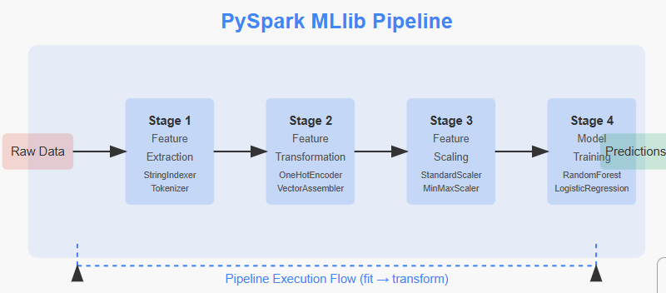

Explanation of Pipeline Stages:
- Data Preparation:
  - Load email data with text content and spam/ham labels
  - Split data into training and test sets
- Label Indexing (StringIndexer):
  - Converts text labels "spam" and "ham" to numerical indices 0 and 1
- Text Processing:
  - Tokenizer: Splits email text into individual words
  - StopWordsRemover: Removes common words that don't provide much signal
- Feature Engineering (HashingTF):
  - Converts text tokens into numerical feature vectors
  - Uses the hashing trick to map words to fixed-size feature vectors
- Model Training (LogisticRegression):
  - Uses logistic regression to classify emails as spam or not
- Hyperparameter Tuning (CrossValidator):
  - Tests different combinations of parameters:
    - Number of features (500 vs 1000)
    - Regularization parameter (0.01 vs 0.1)
  - Uses 3-fold cross-validation to find the best combination
- Model Evaluation:
  - Applies the best model to test data
  - Evaluates using AUC (Area Under Curve) metric

4.What are the key differences between RDD, DataFrame, and Dataset in PySpark? Explain their advantages and use cases.
PySpark offers three primary distributed data abstractions: RDD (Resilient Distributed Dataset), DataFrame, and Dataset. Each provides different levels of optimization, type safety, and usability for big data processing tasks.

1. RDD (Resilient Distributed Dataset)
RDDs are the original, foundational data abstraction in Spark.

Key Characteristics:
- Distributed collection of objects: Partitioned across nodes in a cluster
- Immutable: Cannot be changed after creation, only transformed
- Resilient: Can recover from node failures automatically
- Type-preserving operations: Maintains the same data type throughout transformations
- Lazy evaluation: Operations are only executed when an action is called
- Manual optimization: No built-in optimizer, relies on user knowledge

Advantages:
- Complete control: Fine-grained control over data processing
- Flexibility: Works with any serializable data type
- Custom partitioning: Control over data distribution across the cluster
- Low-level transformations: Access to map, flatMap, filter, etc.

Use Cases:
- Unstructured data: Text processing, raw data without a schema
- Complex algorithms: Custom processing logic not easily expressed in SQL
- Legacy applications: Maintaining older Spark code
- Specialized optimization: When manual performance tuning is required
# Creating and working with an RDD
rdd = sc.parallelize([1, 2, 3, 4, 5])
mapped = rdd.map(lambda x: x * x)
filtered = mapped.filter(lambda x: x > 10)

result = filtered.collect() # Action that triggers execution 2. DataFrame
DataFrames provide a higher-level, structured API built on top of RDDs.

Key Characteristics:
- Tabular data structure: Organized into named columns
- Schema-aware: Understands column names and data types
- Catalyst optimizer: Automatic query optimization
- Tungsten execution engine: Efficient memory management
- Language-agnostic: Consistent API across languages
- SQL integration: Can be queried using SQL syntax

Advantages:
- Performance optimizations: 2-5x faster than RDDs for structured data
- Simplified API: More intuitive operations (select, filter, groupBy)
- Interoperability: Works with various file formats (CSV, JSON, Parquet)
- Integration: Works well with Spark SQL, MLlib, and Streaming
- Memory efficiency: Binary in-memory format instead of Java objects

Use Cases:
- Data engineering tasks: ETL operations, data preprocessing
- SQL-like analytics: Business intelligence and reporting
- Machine learning preparation: Feature engineering for ML models
- Structured data processing: Working with tabular data from databases
# Creating and working with a DataFrame
df = spark.createDataFrame([(1, "John"), (2, "Anna")], ["id", "name"])
filtered_df = df.filter(df.id > 1)

result = filtered_df.select("name").collect()

3. Dataset
Datasets combine the benefits of RDDs (type safety) and DataFrames (optimization).

Key Characteristics:
- Typed interface: Compile-time type checking (primarily in Scala/Java)
- Object-oriented: Work with domain-specific objects
- Catalyst optimizer: Same optimization as DataFrames
- Encoders: Specialized serialization for efficient processing
- In PySpark: Dataset API is unified with DataFrame API

Advantages:
- Type safety: Catch errors at compile time (in Scala/Java)
- Object-oriented programming: Work with domain objects naturally
- Performance optimizations: Benefit from all DataFrame optimizations
- Serialization efficiency: Better than Java serialization used in RDDs

Use Cases:
- Production applications: Where type safety is critical
- Complex business logic: Operations on domain-specific objects
- Scala/Java development: Not a significant benefit in Python
- Enterprise applications: Combining performance with type safety
// This is Scala code - not applicable in PySpark
case class Person(id: Long, name: String)
val dataset = spark.createDataset(Seq(Person(1, "John"), Person(2, "Anna")))
val filtered = dataset.filter(_.id > 1)

Comparative Analysis

1. Schema and Structure
- RDD: No schema enforcement, works with any data structure
- DataFrame: Enforced schema with named columns and data types
- Dataset: Schema plus compile-time type information (Scala/Java)

2. Performance
- RDD: Base performance, no built-in optimizations
- DataFrame: Optimized execution via Catalyst and Tungsten
- Dataset: Same optimizations as DataFrame with efficient encoders

3. API Usability
- RDD: Low-level, functional API (map, flatMap, reduceByKey)
- DataFrame: SQL-like, declarative API (select, filter, groupBy)
- Dataset: Type-safe, object-oriented API (in Scala/Java)

4. Use in PySpark
- RDD: Fully supported but less optimized
- DataFrame: Primary, recommended API for most use cases
Dataset: Does not exist as a separate entity in Python (same as DataFrame)

- Explain the role of SparkSession in PySpark. How does it manage interactions between Spark components? Provide an example.
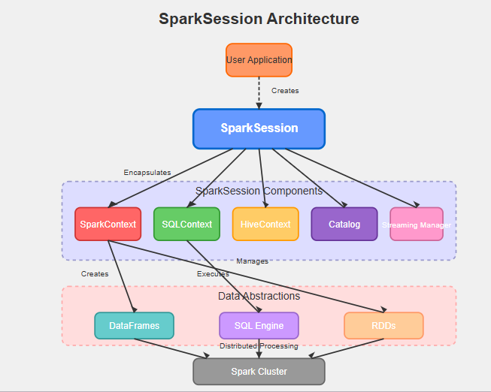
SparkSession serves as the unified entry point for interacting with Spark functionality in PySpark applications. It essentially encapsulates SparkContext, SQLContext, HiveContext, and other contexts into a single, cohesive interface.

Core Functions of SparkSession
- Unified Entry Point: SparkSession provides a single point of entry to interact with underlying Spark functionality.
- DataFrame and Dataset API: It allows you to create DataFrames and Datasets, which are distributed collections of data organized into named columns.
- SQL Operations: SparkSession enables you to run SQL queries against your data.
- Catalog Access: It provides access to the catalog for managing tables and views.
- Configuration Management: SparkSession allows you to set and retrieve Spark configurations.

Managing Interactions Between Components
As shown in the diagram, SparkSession orchestrates interactions between:
- SparkContext: The core of Spark, responsible for connecting to Spark clusters and creating RDDs.
- SQLContext: Provides SQL functionality.
- HiveContext: Adds Hive support.
- Catalog: Manages metadata about tables and views.
- StreamingQueryManager: Manages streaming queries.
The diagram illustrates how the user application interacts with the SparkSession, which then manages all the underlying components and their connections to the Spark cluster.

Example
Here's a basic example showing how to create and use a SparkSession:
from pyspark.sql import SparkSession

# Create a SparkSession
spark = SparkSession.builder \
.appName("MySparkApplication") \
.config("spark.some.config.option", "some-value") \
.getOrCreate()

# Create a DataFrame
data = [("Alice", 34), ("Bob", 45), ("Charlie", 29)]
df = spark.createDataFrame(data, ["Name", "Age"])

# Register a temporary view
df.createOrReplaceTempView("people")

# Run SQL query
result = spark.sql("SELECT * FROM people WHERE Age > 30")
result.show()

# Access the SparkContext
sc = spark.sparkContext
rdd = sc.parallelize([1, 2, 3, 4, 5])
print(rdd.count())

# Stop the session when done
spark.stop()

- Discuss the importance of lazy evaluation in PySpark. How does it improve performance in large-scale data processing?
Lazy evaluation is a fundamental optimization strategy in PySpark that significantly enhances performance when processing large-scale datasets. This approach delays the execution of transformations until an action is explicitly triggered, creating a powerful mechanism for optimizing distributed data processing workflows.

Core Principles of Lazy Evaluation in PySpark
In PySpark, operations fall into two categories:
- Transformations: Operations like map(), filter(), and join() that define a new DataFrame/RDD but don't execute computations
- Actions: Operations like count(), collect(), or save() that trigger actual computation and return results
When transformations are applied, PySpark merely records the operation in a directed acyclic graph (DAG) of computations, without processing any data. Only when an action is called does Spark execute the entire chain of transformations.

Performance Benefits for Large-Scale Data Processing

1. Optimized Execution Plans
Lazy evaluation allows Spark's Catalyst Optimizer to analyze the complete chain of operations before execution. This enables:
- Query optimization through predicate pushdown
- Column pruning to minimize data reading
- Join optimizations based on the full context
- Automatic operation reordering to minimize data movement
For example, when filtering data before a join, Spark can push filters down to source data, drastically reducing the volume of data processed in subsequent operations.

2. Minimized I/O Operations
By delaying execution until necessary, Spark can:
- Consolidate multiple disk or network I/O operations
- Avoid processing intermediate results that don't contribute to the final output
- Reduce the number of data shuffles across the cluster
Consider a workflow involving multiple filters and aggregations. Without lazy evaluation, each step would materialize intermediate results, potentially requiring multiple full data scans.

3. Resource Efficiency
Lazy evaluation enables more efficient resource utilization by:
- Avoiding unnecessary computation on data that may be filtered out later
- Minimizing memory usage by processing only required data partitions
- Allowing for better task scheduling across the cluster

4. Stage-Based Execution
Spark's stage-based execution model, enabled by lazy evaluation, breaks computations into stages separated by shuffle operations, allowing:
- Parallel execution of independent stages
- Recovery from failures at the stage level rather than recomputing entire jobs
- More efficient distribution of work across executors

Practical Implications
The following example illustrates lazy evaluation's benefits:
# This chain of transformations builds a logical plan but executes nothing
filtered_data = df.filter(df.age > 25)
.select("name", "age", "salary")
.filter(df.salary > 50000)
.groupBy("age")
.agg({"salary": "avg"})

# The plan is optimized before execution
# The action triggers actual computation with the optimal execution plan
result = filtered_data.collect()

7What is Spark Structured Streaming? How does it differ from traditional batch processing?
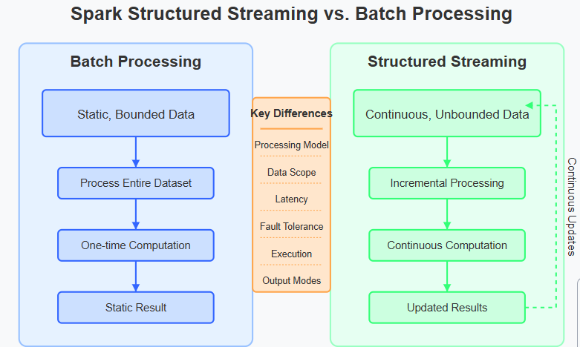
Spark Structured Streaming is a scalable and fault-tolerant stream processing engine built on the Spark SQL engine. It allows you to express streaming computations the same way you would express batch computations on static data.

Core Concepts of Structured Streaming
Structured Streaming treats a stream of data as an unbounded table that continuously grows over time. Each new piece of data arriving in the stream is like a new row being appended to this table. This model simplifies stream processing by letting you use the same DataFrame/Dataset APIs you would use for batch processing.

Differences from Traditional Batch Processing
Structured Streaming vs Batch Processing
Click to open image
Tap to open

1. Processing Model
- Batch Processing: Processes static, bounded datasets with a defined beginning and end.
- Structured Streaming: Processes continuous, unbounded data streams incrementally as data arrives.

2. Data Scope
- Batch Processing: Operates on complete datasets at once.
- Structured Streaming: Processes micro-batches or individual records as they arrive.

3. Latency
- Batch Processing: Higher latency, as processing starts only after all data is collected.
- Structured Streaming: Lower latency, as data is processed soon after arrival.

4. Execution Model
- Batch Processing: Executes once and terminates when complete.
- Structured Streaming: Continuously runs, processing new data as it arrives.

5. Fault Tolerance
- Batch Processing: Typically restarts the entire job if a failure occurs.
- Structured Streaming: Maintains checkpoints for exactly-once processing semantics, allowing recovery without duplicate processing.

6. Output Modes
- Batch Processing: Produces a single, final output.
- Structured Streaming: Supports multiple output modes:
  - Append: Adds only new rows to output sink
  - Complete: Writes the full result table to the sink
  - Update: Writes only rows that were updated since the last trigger

Example Use Cases
Structured Streaming is ideal for:
- Real-time analytics dashboards
- Fraud detection systems
- IoT sensor data processing
- Log processing and monitoring

Continuous ETL pipelines

8.Explain the concept of event-time processing in Spark Structured Streaming. How does it handle late-arriving data?
Event-time processing is a critical concept in stream processing that deals with data based on when events actually occurred rather than when they arrive in the system. This approach is essential for applications where the timing of events matters, such as user behavior analysis, IoT sensor monitoring, and financial transactions.

Event-Time vs. Processing-Time
In streaming systems, there are two primary time concepts:
- Event-Time: When the event actually occurred in the real world (based on data within the event)
- Processing-Time: When the event is observed and processed by the streaming system
These times can differ significantly due to:
- Network delays
- Device connectivity issues
- System backpressure
- Queue processing delays
- System outages

Event-Time Windows in Structured Streaming
Spark Structured Streaming allows you to group and aggregate data based on event time windows:
# Group events into 1-hour windows based on event_time
windowedCounts = df \
.withWatermark("event_time", "10 minutes") \
.groupBy(window("event_time", "1 hour")) \
.count()
This creates tumbling windows where events are grouped by when they occurred, regardless of when they arrive for processing.

The Challenge of Late-Arriving Data
As shown in the diagram, event-time processing faces a fundamental challenge: data can arrive out of order. For example:
- An event that occurred at t2 might arrive after events from t3 or t4
- Some events might be extremely delayed
Without proper handling, this can lead to:
- Incomplete results
- Multiple updates to the same window
- Unbounded state growth (memory issues)

Watermarks: Managing Late Data
A watermark is a threshold that defines how long the system will wait for late data. In the diagram:
- The current watermark is set at (t3 - 10min)
- Events with timestamps before this watermark that haven't arrived yet are considered "too late"
- The system will no longer update results for windows that end before the watermark

Setting Watermarks in Spark
Watermarks are defined using the withWatermark() method:
# Set a watermark of 10 minutes
df = df.withWatermark("event_time", "10 minutes")
This tells Spark to wait up to 10 minutes (in event time) for late data before considering windows complete.

How Spark Handles Different Data Arrival Scenarios
As illustrated in the diagram:
- On-time events (green): Processed normally and included in their respective windows
- Late but acceptable events (orange): Events arriving after their event time but before the watermark
  - Added to their appropriate windows
  - Trigger recalculation of results for those windows
- Too late events (red): Events arriving after the watermark has passed their window
  - Typically dropped to maintain system stability
  - Optionally can be routed to a separate "late data" sink for analysis

Output Modes for Event-Time Processing
The handling of late data depends on the output mode:
- Append Mode: Results for a window are output only when the watermark passes the window end time
  - Guarantees each window's result is output only once
  - Provides highest result completeness
- Update Mode: Results are updated whenever new data arrives for a window
  - Provides more real-time updates
  - Same window may have multiple result versions
- Complete Mode: The entire result table is output on each trigger
  - Does not use watermarks for dropping data
  - Can lead to unbounded state

Benefits of Event-Time Processing
- Temporal Accuracy: Results reflect when events actually occurred
- Consistent Results: Same results regardless of data arrival patterns
- Resilience: Handles delays, outages, and network issues gracefully
- State Management: Watermarks enable automatic cleanup of old state
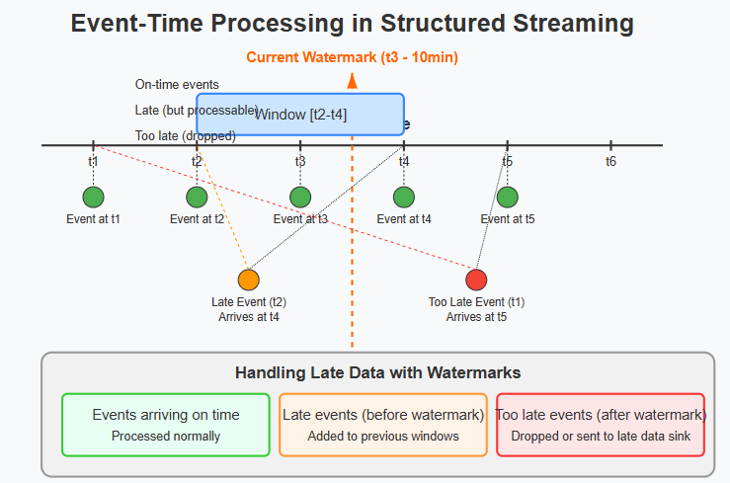

9.Explain the micro-batch processing model in Spark Structured Streaming. How does it work internally?
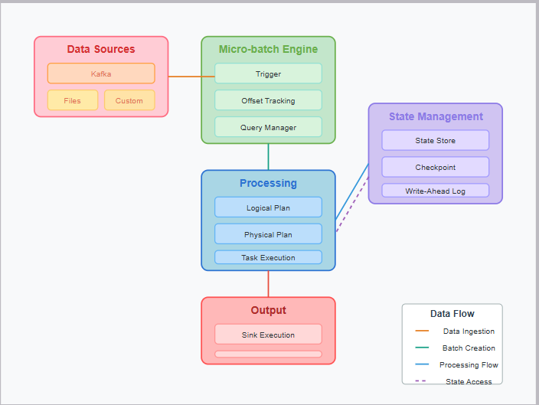

Key Components:
- Data Sources
  - Kafka, file systems, and custom sources generate streaming data
  - Each source has its own offset tracking mechanism
- Micro-batch Engine
  - Trigger determines when to start a new micro-batch (time-based, once, or continuous)
  - Offset tracking manages exactly which data has been processed
  - Query Manager maintains the lifecycle of streaming queries
- Processing Pipeline
  - Logical Plan defines the operations to perform (similar to batch processing)
  - Physical Plan optimizes execution through Catalyst optimizer
  - Task Execution distributes work across the Spark cluster
- State Management
  - State Store maintains stateful operation data (for aggregations, joins, etc.)
  - Checkpoint stores recovery information for fault tolerance
  - Write-Ahead Log ensures data consistency and exactly-once processing
- Output System
  - Sink Execution writes results to external systems
  - Provides atomic output to ensure consistency

Data Flow:
The system processes data in these stages:
- Source data arrives and is collected into micro-batches
- Each micro-batch is processed as a Spark job
- State is maintained across micro-batches for stateful operations
- Results are sent to output sinks
- Checkpoints record progress for fault tolerance

10.How does Spark Structured Streaming achieve end-to-end exactly-once semantics? Discuss the role of sinks and fault tolerance.
Spark Structured Streaming achieves end-to-end exactly-once semantics through a carefully designed system that coordinates input sources, processing, state management, and output sinks. Here's how the different components work together

Source-to-Sink Guarantees

Input Source Management
- Offset Tracking: Structured Streaming precisely tracks which data has been processed by maintaining offset information for each source.
  - For Kafka: Manages partition offsets
  - For files: Tracks which files and which parts have been processed
  - For custom sources: Uses source-specific offset tracking mechanisms
- Idempotent Reading: When recovering from a failure, the system re-reads data from exactly where it left off, avoiding duplicate processing.

Processing Guarantees
- Deterministic Operations: All operations must produce the same result given the same input, ensuring consistency during reprocessing.
- Atomic Micro-batches: Each micro-batch is processed as an atomic unit – either completely or not at all.
- State Management: For stateful operations, the state store maintains consistent snapshots that can be recovered.

The Critical Role of Sinks
Sinks are crucial for end-to-end exactly-once guarantees and must satisfy specific requirements:

Output Sink Types and Guarantees
- Idempotent Sinks: Can receive the same data multiple times without creating duplicates.
  - Example: HDFS with unique IDs as filenames
- Transactional Sinks: Support atomic commits that can be rolled back if a job fails.
  - Example: Kafka with producer transactions
- Specialized Sinks: Built specifically for exactly-once semantics.
  - Examples: Delta Lake, Parquet files with metadata

Implementation Mechanisms
To achieve exactly-once semantics with sinks, Structured Streaming uses:
- Two-Phase Commits:
  - First phase writes data in a temporary location
  - Second phase atomically commits the data only if the entire batch succeeds
- Output Metadata:
  - Tracks which batches have been committed to which sinks
  - Stored alongside checkpoints for recovery
- Idempotent Writes:
  - Uses batch IDs to ensure duplicate batches aren't written to the sink

Fault Tolerance Mechanisms
The fault tolerance system is the backbone of exactly-once guarantees:

Checkpointing
- What's Checkpointed:
  - Source offsets (what data has been read)
  - Committed batch IDs (what has been written)
  - State snapshots (intermediate results)
  - Processing metadata (query details)
- Recovery Process:
  - On failure, the system restarts from the last checkpoint
  - Re-reads data from sources based on stored offsets
  - Rebuilds the exact same state
  - Verifies which batches were committed and only outputs uncommitted results

Write-Ahead Logs (WAL)
- Operation Logging: Every operation is recorded before execution
- Consistent State: Ensures state can be reconstructed consistently after failure
- Atomic Updates: State changes are written atomically

Practical Example of End-to-End Exactly-Once
Consider a Kafka-to-JDBC streaming pipeline:
- Read Phase:
  - Kafka offsets are tracked for each partition
  - Data is read up to specific offsets for each micro-batch
- Processing Phase:
  - Data is transformed and aggregated
  - State is maintained in the state store with WAL
- Write Phase:
  - JDBC sink performs writes in a transaction
  - Transaction is committed only if the entire batch is successful
  - Offset information is stored in the same transaction
- Checkpointing:
  - After successful write, checkpoint is updated with:
    - Kafka offsets that have been processed
    - Batch ID that has been committed to JDBC
    - Latest state store snapshot
- Recovery:
  - If a failure occurs, the system:
    - Reads checkpoint data
    - Resumes from the correct Kafka offsets
    - Rebuilds state from checkpoint
Avoids rewriting already committed batches

11.What are Streaming DataFrames in Spark Structured Streaming? How do they differ from static DataFrames?
Streaming DataFrames in Spark Structured Streaming represent unbounded, continuously arriving data, while sharing many characteristics with their static counterparts. Let's explore their key differences and similarities:

Streaming DataFrames
A Streaming DataFrame is an unbounded table that continually grows as new data arrives. It represents a potentially infinite stream of data that's processed incrementally.

Key Characteristics
- Unbounded Nature:
  - Represents a continuous, potentially never-ending data flow
  - Data size is unknown and can grow indefinitely
- Incremental Processing:
- Data is processed in micro-batches or continuously
- Each trigger processes only the new data that has arrived
- Laziness:
- Like static DataFrames, transformations are lazy
- Execution happens only when an output action is defined
- Special Handling:
- Certain operations need special handling (like aggregations over windows)
- Uses stateful processing for operations that need to remember previous data
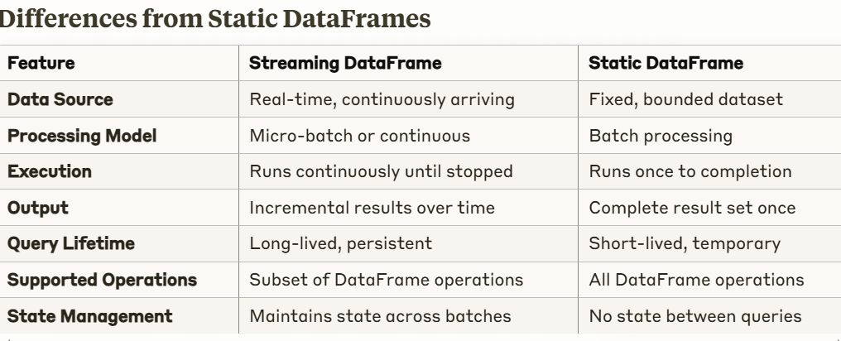

Limitations of Streaming DataFrames
Not all operations available on static DataFrames work on streaming DataFrames:
- Sorting: Global sorting across all data is not supported (only per-batch sorting)
- Limit/Take: Limiting results across the entire stream is not meaningful
- Distinct: Global distinct operations are challenging on infinite data
- Multiple Streaming Aggregations: Some complex multi-level aggregations are restricted
Certain Joins: Some types of joins between streaming DataFrames have limitations

12.Explain the use of readStream and writeStream APIs in Spark Structured Streaming with an example.
The readStream and writeStream APIs are the entry and exit points for data in Spark Structured Streaming applications. They allow you to create streaming DataFrames from various sources and output results to different sinks, respectively.

readStream API (4 marks)
The readStream API creates a streaming DataFrame by connecting to a streaming source.

Key Features:
- Creates an unbounded DataFrame that continuously ingests new data
- Supports multiple sources including Kafka, files, sockets, and custom sources
- Configurable options for each source type (e.g., Kafka topics, file formats)
- Schema inference or explicit schemas to define the structure of incoming data
Example - Reading from Kafka:
// Create a streaming DataFrame representing Kafka data
val kafkaStreamDF = spark
.readStream
.format("kafka")
.option("kafka.bootstrap.servers", "host1:port1,host2:port2")
.option("subscribe", "topic1")
.option("startingOffsets", "earliest")
.load()

// The schema includes key, value, topic, partition, offset, timestamp, etc.
val parsedDF = kafkaStreamDF
.selectExpr("CAST(key AS STRING)", "CAST(value AS STRING)")
.as[(String, String)]

writeStream API (4 marks)
The writeStream API defines how streaming results should be output and initiates the streaming query.

Key Features:
- Output mode selection (complete, append, update)
- Multiple sink types (console, memory, files, Kafka, JDBC, etc.)
- Trigger configuration (processing time intervals, once, continuous)
- Checkpoint location for fault tolerance
- Query name for monitoring and management
Example - Writing to Console and Files:
// Process the streaming data
val wordCountsDF = parsedDF
.flatMap(_._2.split(" "))
.groupBy("value")
.count()

// Write to console for debugging
val consoleQuery = wordCountsDF
.writeStream
.outputMode("complete")
.format("console")
.trigger(Trigger.ProcessingTime("10 seconds"))
.start()

// Simultaneously write to Parquet files for persistence
val fileQuery = wordCountsDF
.writeStream
.outputMode("append")
.format("parquet")
.option("path", "/data/word-counts")
.option("checkpointLocation", "/checkpoints/word-counts")
.partitionBy("date")
.trigger(Trigger.ProcessingTime("1 minute"))
.start()

// Wait for queries to terminate
spark.streams.awaitAnyTermination()

13.Discuss the importance of trigger in Spark Structured Streaming. How does it affect streaming query execution?
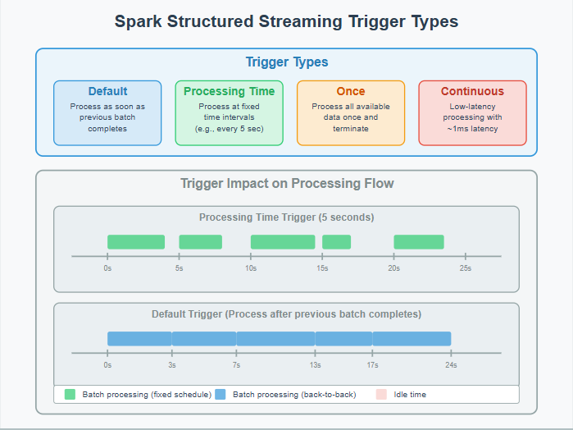
Triggers are a critical component in Spark Structured Streaming that control when micro-batches are processed. They dictate the timing and rhythm of stream processing, directly affecting latency, throughput, and resource utilization.

Types of Triggers
Spark Structured Streaming offers four distinct trigger types, each serving different use cases:
- Default Trigger
  - Processes data as soon as the previous micro-batch completes
  - Creates a continuous chain of processing without delay
  - Maximizes throughput by keeping the system constantly busy
df.writeStream
// No explicit trigger = Default
.start()
- Processing Time Trigger
- Processes data at fixed time intervals (e.g., every 5 seconds)
- Provides predictable processing cadence regardless of data volume
- Useful for controlling resource usage and managing downstream system load
df.writeStream
.trigger(Trigger.ProcessingTime("5 seconds"))
.start()
- Once Trigger
- Processes all available data exactly once, then terminates
- Acts like a batch job but processes streaming sources
- Useful for periodic jobs that need to process accumulations of streaming data
df.writeStream
.trigger(Trigger.Once())
.start()
- Continuous Trigger
- Enables low-latency continuous processing (~1ms)
- Uses a different execution model than micro-batch
- Limited to simpler operations (not all DataFrame operations supported)
df.writeStream
.trigger(Trigger.Continuous("1 second")) // checkpoint interval
.start()

How Triggers Affect Execution

1. Latency Impact
- Default Trigger: Latency depends on processing time; can be high with large batches
- Processing Time: Predictable latency bound by the trigger interval
- Once Trigger: High latency as it processes all available data
- Continuous: Lowest latency (~1ms) as it processes records immediately

2. Resource Utilization
- Default Trigger: Maximum resource utilization (no idle time)
- Processing Time: Potential idle periods between batches, allowing resource sharing
- Once Trigger: Temporary resource usage, then release
- Continuous: Constant but more evenly distributed resource usage

3. Throughput Considerations
- Default Trigger: Optimizes for maximum throughput
- Processing Time: May reduce overall throughput but provides stable processing
- Once Trigger: Optimized for one-time bulk processing
- Continuous: May reduce throughput due to overhead of per-record processing

4. Batch Size Effects
- Default & Once: Potentially large, variable batch sizes
- Processing Time: More consistent batch sizes, dependent on data arrival rate
- Continuous: Extremely small batches (potentially single records)

14.Describe different data sources supported in Spark Structured Streaming. How does Spark handle continuous data ingestion?
Spark Structured Streaming is designed to handle continuous data ingestion from various sources. Here's an overview of the supported data sources and how Spark handles continuous data processing:

Supported Data Sources

File-based Sources
- File Source: Reads files from a directory as they appear. Supports formats like JSON, CSV, Parquet, ORC, and text files.
- File Stream Source: Monitors a directory for new files and processes them as a stream.

Messaging Systems
- Kafka: Native integration with Apache Kafka to consume data from Kafka topics.
- Kinesis: Reads data from Amazon Kinesis streams (available through Spark-AWS integration).
- JDBC: Can pull data from databases through incremental queries.

Socket Source
- Used primarily for testing, allows connecting to a socket for streaming text data.

Rate Source
- A test source that generates data at a specified rate, useful for benchmarking.

Custom Sources
- Developers can implement custom sources using the Source interface.

How Spark Handles Continuous Data Ingestion
Spark Structured Streaming handles continuous data ingestion through:
- Micro-Batch Processing
  - Default processing mode
  - Divides the continuous stream into small batches
  - Each batch is processed as a Spark SQL batch query
  - Provides exactly-once processing guarantees
  - Typical latency: 100ms or higher
- Continuous Processing (introduced in Spark 2.3)
  - Low-latency mode (as low as 1ms)
  - Processes data as soon as it arrives
  - Currently supports limited operations
  - Provides at-least-once guarantee
  - Ideal for scenarios requiring minimal latency
- Stateful Processing
  - Maintains state across batches for operations like windowing
  - Uses a state store to track intermediate results
  - Allows complex operations like joins, aggregations on streaming data
- Fault Tolerance and Checkpointing
  - Uses checkpointing to record offset information
  - Enables recovery from failures
  - Ensures exactly-once processing semantics
  - Saves state to a reliable storage system (HDFS, S3)
- Trigger Options
- Default: Process as soon as previous batch completes
- Fixed interval: Process at specified intervals
- One-time: Process available data and then stop
- Continuous: Process with minimal latency
- Watermarking
  - Handles late-arriving data
  - Allows the system to clear old state
  - Defines how long to wait for late data
15.Explain the role of schema inference in streaming DataFrames. Why is it important in real-time data processing?
Schema inference plays a crucial role in Spark Structured Streaming by automatically determining the structure of incoming data. This is particularly important for real-time data processing for several reasons:

How Schema Inference Works in Streaming DataFrames
When creating a streaming DataFrame, Spark can automatically infer the schema of the incoming data by:
- Sampling Initial Data: For sources like JSON or CSV files, Spark examines a subset of initial data to determine field names and types.
- Source-Specific Inference: Different sources have different inference mechanisms:
  - For Kafka, Spark may infer the schema from the value portion of Kafka records
  - For file-based sources, Spark scans available files to determine structure
- User-Defined Schemas: Alternatively, you can explicitly define the expected schema rather than relying on inference

Importance in Real-Time Data Processing

1. Development Efficiency and Flexibility
Schema inference eliminates the need to pre-define every field structure, allowing developers to:
- Get started quickly without extensive schema design
- Adapt to evolving data structures
- Handle semi-structured data more easily

2. Data Consistency and Validation
- Provides a consistent view of data regardless of when it arrives
- Helps identify structural problems in incoming data early
- Enables validation of incoming data against expected formats

3. Performance Optimization
- Allows Spark to create optimized execution plans based on known data types
- Enables better memory management by allocating appropriate space for each data type
- Supports column pruning and predicate pushdown optimizations

4. Integration with Downstream Systems
- Creates a consistent interface for downstream applications
- Enables seamless integration with existing data pipelines
- Supports schema evolution as requirements change

5. Query Optimization
- Enables the Catalyst optimizer to create efficient query plans
- Supports advanced operations like windowing and aggregations
- Improves join performance by understanding data characteristics

Limitations and Considerations
While schema inference is powerful, there are important considerations:
- Performance Overhead: Initial schema inference adds some latency at startup
- Inference Accuracy: Complex or nested structures might not be inferred correctly
- Schema Evolution: Changes in incoming data structure can cause processing failures
- Default Type Selection: Inferred types might not always be optimal

16.What are stateful operations in Spark Structured Streaming? Explain with an example.
Stateful operations in Spark Structured Streaming are transformations that maintain and use data across multiple batches or events. These operations require Spark to track information about past data to process current and future data correctly.

Key Characteristics of Stateful Operations
- Maintain state information across multiple triggers/micro-batches
- Allow for complex event processing that spans multiple data points over time
- Require checkpointing to ensure fault tolerance
- Often need watermarking to manage state size and handle late data

Common Stateful Operations
- Aggregations: Counting, summing, or averaging values over time
- Window Functions: Processing data within specific time windows
- Streaming Joins: Combining data from multiple streams
- mapGroupsWithState/flatMapGroupsWithState: Custom state management operations
- Deduplication: Removing duplicate events based on keys

Example: Real-time User Session Analysis
Let's examine a concrete example of stateful processing - analyzing user sessions from a stream of website clicks:
from pyspark.sql import SparkSession
from pyspark.sql.functions import col, window, count, sum, expr
from pyspark.sql.types import StructType, StructField, StringType, TimestampType

# Create Spark Session
spark = SparkSession.builder \
.appName("Stateful Session Analysis") \
.getOrCreate()

# Define schema for incoming clickstream data
schema = StructType([
StructField("user_id", StringType(), True),
StructField("page_id", StringType(), True),
StructField("event_time", TimestampType(), True),
StructField("action", StringType(), True)
])

# Read stream of clickstream data
clickstream = spark.readStream \
.format("kafka") \
.option("kafka.bootstrap.servers", "kafka:9092") \
.option("subscribe", "user_clicks") \
.load() \
.select(from_json(col("value").cast("string"), schema).alias("data")) \
.select("data.*")

# Add watermark to handle late data - state will be maintained for data within this window
clicks_with_watermark = clickstream \
.withWatermark("event_time", "1 hour")

# Perform stateful windowed aggregation - counts clicks by user in 10-minute windows
user_activity = clicks_with_watermark \
.groupBy(
window(col("event_time"), "10 minutes"),
col("user_id")
) \
.agg(
count("*").alias("click_count"),
sum(expr("case when action = 'purchase' then 1 else 0 end")).alias("purchase_count")
)

# Start the query and write results to console
query = user_activity \
.writeStream \
.outputMode("update") \
.format("console") \
.option("truncate", "false") \
.start()

query.awaitTermination()

How State is Maintained
In this example:
- The system maintains state by keeping track of the number of clicks and purchases for each user within each 10-minute window
- As new data arrives in each micro-batch, Spark updates these counters instead of recalculating from scratch
- The state store holds intermediate aggregation results until the window is complete
- The watermark specification (withWatermark("event_time", "1 hour")) tells Spark it can discard state for windows that are more than 1 hour old, preventing unbounded state growth

17.How does Spark handle window operations on Streaming DataFrames? Provide an example of tumbling and sliding windows.
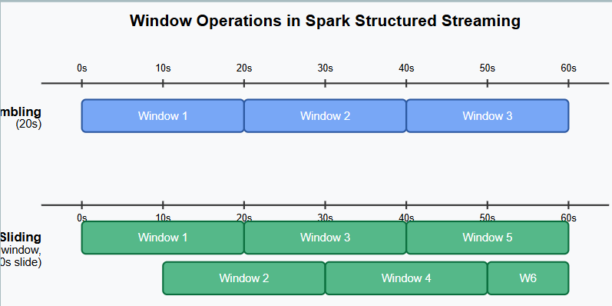
Spark's Structured Streaming provides robust support for window operations, which are essential for time-based analytics on streaming data. Window operations group records based on time intervals, enabling time-based aggregations on continuous data.

Types of Windows in Spark Structured Streaming
Spark primarily supports two types of window operations:
- Tumbling Windows (Fixed, Non-overlapping Windows)
- Sliding Windows (Overlapping Windows)

Tumbling Windows
Tumbling windows divide the data stream into non-overlapping, fixed-size time intervals. Each event belongs to exactly one window.
Key Characteristics:
- Fixed window size (duration)
- No overlap between windows
- Simple to reason about
- Lower resource requirements

Sliding Windows
Sliding windows allow overlap between windows by "sliding" the window forward by a specified interval smaller than the window size.
Key Characteristics:
- Window duration and slide interval
- Events can belong to multiple windows
- More granular analysis
- Higher resource requirements due to data repetition

Window Implementation in Spark
Spark implements windows through the window function in the SQL API:
import org.apache.spark.sql.functions.{window, col, sum}

// Define windows
val tumblingWindows = df.groupBy(
window($"timestamp", "10 minutes"))
.agg(sum("value"))

val slidingWindows = df.groupBy(
window($"timestamp", "10 minutes", "5 minutes"))
.agg(sum("value"))

Key Considerations for Window Operations
- State Management: Window operations are stateful, requiring Spark to maintain state across batches.
- Watermarking: Essential for managing state growth and handling late data:
python
Copy
# Add a watermark to allow for late data up to 10 minutes
.withWatermark("timestamp", "10 minutes")
- Output Modes:
  - complete: All aggregates are output
  - update: Only updated aggregates are output
  - append: Only finalized aggregates after watermark are output
- Performance Trade-offs:
  - Tumbling windows generally require less resource usage
  - Sliding windows provide more granular insights but at higher computational cost
  - Window duration affects state size and memory requirements
- Time Extraction:
  - Event time: When the event actually occurred
  - Processing time: When Spark processes the event
  - Event time is generally preferred for accurate analytics

18. Discuss the difference between append, update, and complete output modes in Spark Structured Streaming. Provide examples of their use cases using diagram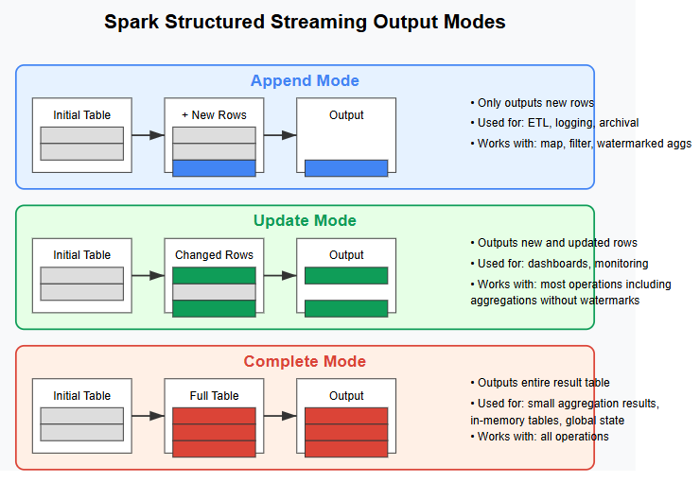

Output Modes in Spark Structured Streaming
Spark Structured Streaming provides three distinct output modes that control how data is written to output sinks: Append, Update, and Complete. Each mode serves different use cases and works with specific types of operations.

1. Append Mode
In Append mode, only new rows that have been added to the result table since the last trigger are written to the sink.

Key Characteristics:
- Outputs only new records
- Never updates existing data
- Most efficient in terms of write operations
- Cannot be used with aggregations without watermarks

Compatible Operations:
- Select, map, filter operations
- Aggregations with watermarks
- Joins with watermarks

Ideal For:
- ETL pipelines storing processed data
- Archiving events after processing
- Log processing and storage
- Data migration scenarios

2. Update Mode
In Update mode, all rows that were updated since the last trigger will be written to the sink.

Key Characteristics:
- Outputs both new rows and rows with updated values
- Does not output unchanged rows
- Requires sinks that can handle updates
- More efficient than Complete when most rows remain unchanged

Compatible Operations:
- Most operations including aggregations without watermarks
- Stateful processing operations

Ideal For:
- Real-time dashboards and visualizations
- Monitoring applications
- Key-value stores requiring incremental updates
- Computing running metrics

3. Complete Mode
In Complete mode, the entire result table is written to the sink after every trigger.

Key Characteristics:
- Outputs the entire result table each time
- Most resource-intensive option
- Suitable only for smaller result sets
- Required for certain types of aggregations

Compatible Operations:
- Compatible with all operations
- Required for aggregations without watermarks

Ideal For:
- Leaderboards and rankings
- Small aggregation results requiring full state
- In-memory tables for querying
- Global state management
- When downstream systems expect complete data replacement

Selection Guidelines
When choosing an output mode, consider:
- Data Volume: For large result sets, avoid Complete mode
- Update Pattern: If most results change with each trigger, Update and Complete have similar performance
- Sink Capabilities: Some sinks may only support specific modes
- Operation Types: Some operations restrict available modes
- State Management: Complete mode requires maintaining the entire state

UNIT 4
- Explain the architectural components of Apache Kafka and their roles in a distributed messaging system.
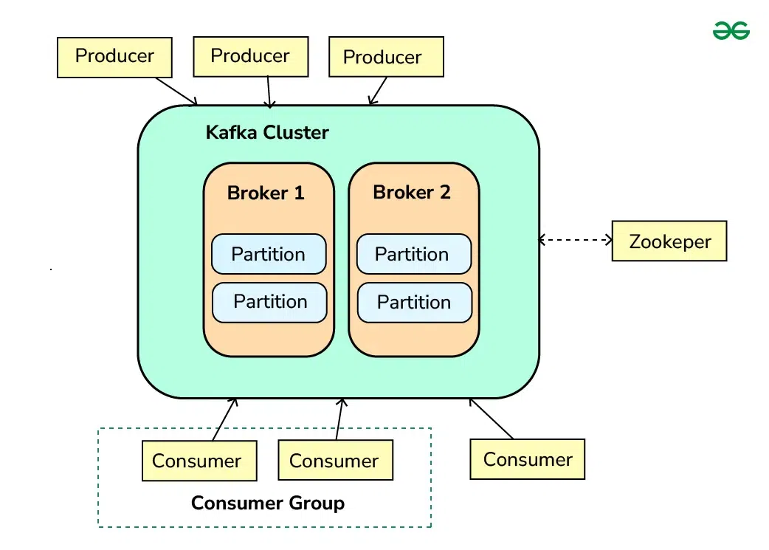

Core Components of Kafka Architecture
- Kafka Cluster: A Kafka cluster is a distributed system composed of multiple Kafka brokers working together to handle the storage and processing of real-time streaming data. It provides fault tolerance, scalability, and high availability for efficient data streaming and messaging in large-scale applications.
- Brokers: Brokers are the servers that form the Kafka cluster. Each broker is responsible for receiving, storing, and serving data. They handle the read and write operations from producers and consumers. Brokers also manage the replication of data to ensure fault tolerance.
- Topics and Partitions: Data in Kafka is organized into topics, which are logical channels to which producers send data and from which consumers read data. Each topic is divided into partitions, which are the basic unit of parallelism in Kafka. Partitions allow Kafka to scale horizontally by distributing data across multiple brokers.
- Producers: Producers are client applications that publish (write) data to Kafka topics. They send records to the appropriate topic and partition based on the partitioning strategy, which can be key-based or round-robin.
- Consumers: Consumers are client applications that subscribe to Kafka topics and process the data. They read records from the topics and can be part of a consumer group, which allows for load balancing and fault tolerance. Each consumer in a group reads data from a unique set of partitions.
- ZooKeeper: ZooKeeper is a centralized service for maintaining configuration information, naming, providing distributed synchronization, and providing group services. In Kafka, ZooKeeper is used to manage and coordinate the Kafka brokers. ZooKeeper is shown as a separate component interacting with the Kafka cluster.
- Offsets : Offsets are unique identifiers assigned to each message in a partition. Consumers will use these offsets to track their progress in consuming messages from a topic.
Key Architectural Characteristics:
- Distributed and scalable messaging system
- High throughput and low latency
- Fault-tolerant with message replication
- Supports real-time and batch processing

- Describe the process of creating and managing Kafka topics. What are the key parameters to consider?

Kafka Topic Management
One of the fundamental aspects of working with Kafka is managing topics. Topics are the categories to which records are sent by producers and from which records are received by consumers.

1. Creating Topics
To create a topic in Kafka, you can use the kafka-topics.sh script, which is included in the Kafka distribution. Here is an example command to create a Kafka topic:
./bin/kafka-topics.sh --create --topic topic_name --bootstrap-server localhost:9092 --replication-factor 1 --partitions 1
Command Explanation:
- --create: This flag is used to create a new topic.
- --topic topic_name: Specifies the name of the topic that needs to be created.
- --bootstrap-server localhost:9092: Specifies the Kafka broker to connect to. You can replace localhost:9092 with your actual broker address.
- --replication-factor 1: Specifies the replication factor for the topic, which indicates how many copies of each partition should be maintained. In this example, it is set to 1.
- --partitions 1: Specifies the number of partitions for the topic. In this example, it is set to 1.

2. Topic Configurations
The Kafka topics have several configurations that determine their behavior. If no topic configuration is provided then the default server properties were used. You can create a topic using "kafka-topic" tool and "--config" option. We can modify the configuration using "kafka-configs" and "--alter" option.
Example: Creating a Topic with Configurations
./bin/kafka-topics.sh --create --topic topic_name --bootstrap-server localhost:9092 --replication-factor 1 --partitions 1 --config retention.ms=604800000
Example: Modifying Topic Configurations
./bin/kafka-configs.sh --alter --entity-type topics --entity-name topic_name --add-config retention.ms=259200000

3. Topic Partitions and Replication
- Partitions: Topic partitions are a fundamental concept in Kafka that allow data to be parallelized and distributed among multiple brokers. Each partition is an ordered collection of messages that are immutable. When creating a topic, you specify the number of partitions using the --partitions flag.
- Replication: Kafka allows replication of data across multiple brokers to ensure data durability and fault tolerance. Each partition can have one or more replicas. Among these replicas, one serves as the leader, and the others serve as followers. The leader handles all read and write requests for the partition, while the followers replicate the data. If the leader replica fails, one of the follower replicas is elected as the new leader. The replication factor is specified using the --replication-factor flag when creating a topic.
Example: Creating a Topic with Partitions and Replication
./bin/kafka-topics.sh --create --topic topic_name --bootstrap-server localhost:9092 --replication-factor 3 --partitions 4

- Write a detailed explanation of Kafka Producers, including their key configurations and message sending mechanism.
Kafka Producers are going to write data to topics and topics are made of partitions. Now the producers in Kafka will automatically know to which broker and partition to write based on your message and in case there is a Kafka broker failure in your cluster the producers will automatically recover from it which makes Kafka resilient and which makes Kafka so good. So if we look at a diagram to have the data in our topic partitions we’re going to have a producer on the left-hand side sending data into each of the partitions of our topics.
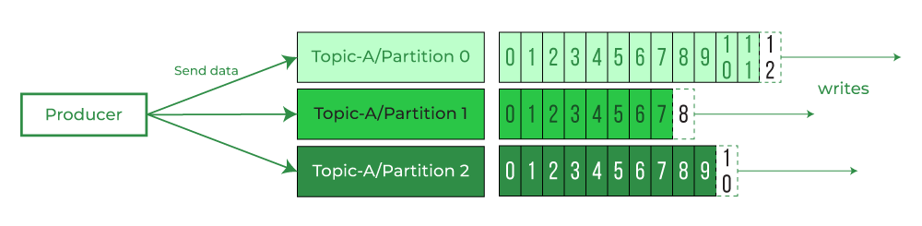

Kafka Message Keys
So alongside the message value, we can choose to send a message key and that key can be whatever you want it could be a string, it could be a number whatever you want and it turns out that if you don’t send the key, the key is set to null then the data will be sent in a Round Robin fashion to make it very simple. So that means that your first message is going to be sent to partition 0, and then your second message to partition 1 and then partition 2, and so on.
This is why it’s called Round Robin, but in case you send a key with your message, all the messages that share the same key will always go to the same partition. So this is a very very important property of Kafka because that means if you need ordering for a specific field, for example, if you have cars and you want to get all the GPS positions in order for that particular car then you need to make sure to have your message key set as the unique identifier for your car i.e carID and so in our car GPS example that we have discussed in this article, Topics, Partitions, and Offsets in Apache Kafka, we need to choose the message key to be equal to carID so that we have all the car positions for that one specific car in order as part of the same partition.
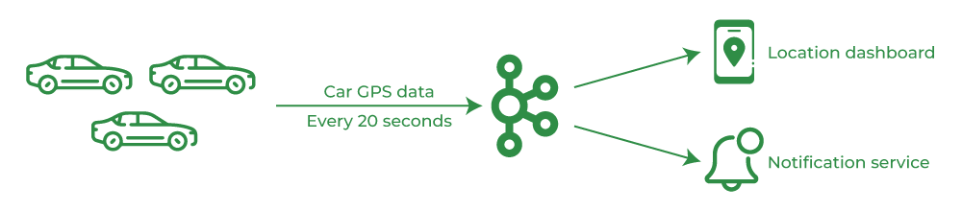

So the second example again if we have the producer sends data to 2 partitions and the key is carID then carID_123 will always go in partition 0, carID_234 as well will always go in partition 0 and carID_345 and carID_456 will always go in partition 1. The idea here again is that you will never find the carID_123 data in partition 1 because of this key property we just mentioned. 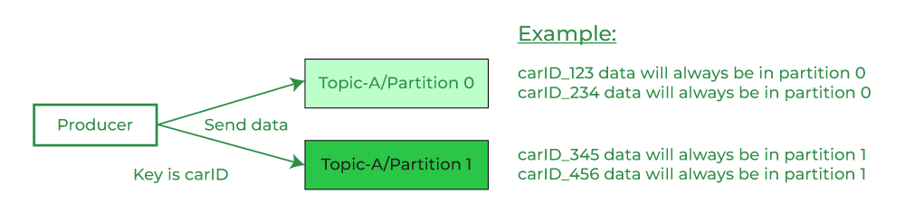 Kafka Message Anatomy
The Kafka messages are created by the producer and the first fundamental concept we discussed is the Key. The key can be null and the type of the key is binary. So binary is 0 and 1, but it can be strings and numbers and we’ll see how this happens to convert a string or a number into a binary.
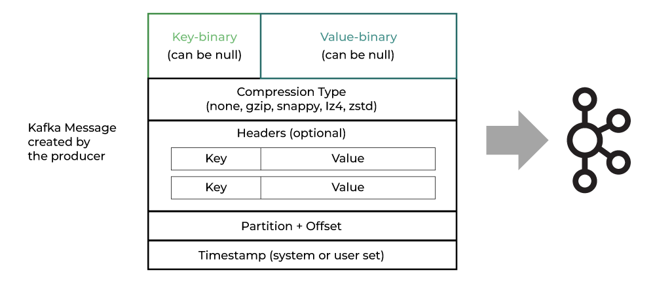
Please refer to the above image. So we have the key which is a binary field that can be null and then we have the value which is the content of your message and again this can be null as well. So the Key-Value is some of the two most important things in your message but there are other things that go into your message. For example, your message can be compressed and so the compression type can be indicated as part of your message. For example, none means no compression but we have four different kinds of compressions available in Kafka that are mentioned below.
- gzip
- snappy
- lz4
- zstd
We also have optional headers for your message. So headers are pairs of key-value and you can have many of those in part of one message and it is common to set them in case you’re trying to add metadata to your messages. Once a message is sent into a Kafka Topic then it will receive a partition number and an offset id. So the partition and the offset are going to be part of the Kafka message and then finally a timestamp alongside the message will be added either by the user or by the system and then that message will be sent to Kafka. So remember that the key is a binary and the value is binary but when we start writing some messages in Kafka we’re obviously going to use some higher-level objects and so to transform these objects into binaries we’re going to use the Producer Serializer.

Producer Serializer
Serializer will indicate how to transform these objects into bytes and they will be used for the key and the value. So say for example that we have the value to be “hello world” and as a string and the key to be “123” and that’s an integer. In that case, we need to set the KeySerializer to be an IntegerSerializer and what this will do internally is that it will convert that integer into bytes, and these bytes will be part of the key which is going to be binary, and the same for the value which is “hello world” as a string. We’re going to use a StringSerializer as the ValueSerializer to convert that string into bytes and again this is going to give us our value as part of a binary field.
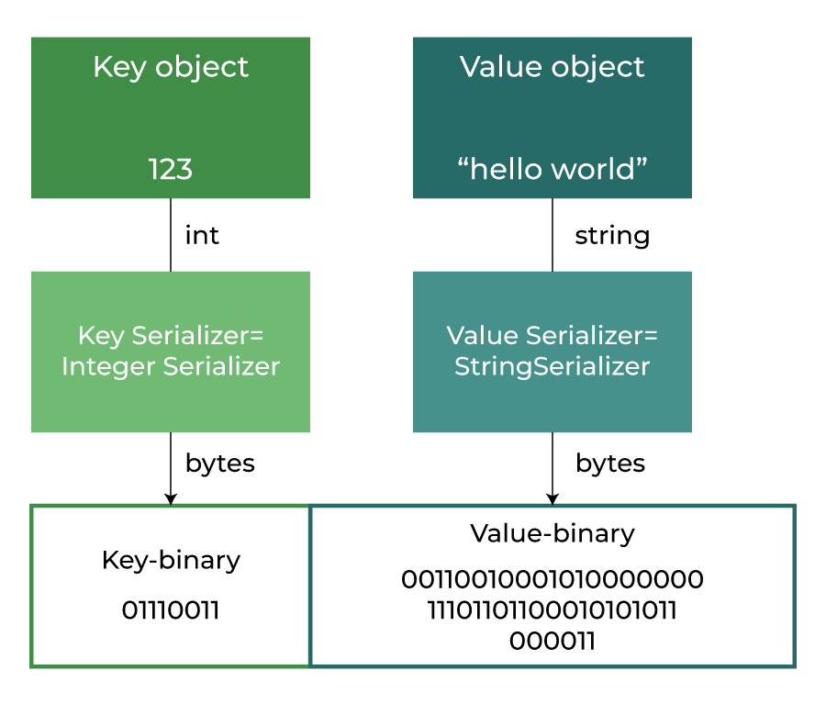

- Explain how a multi-broker Kafka cluster is configured and the benefits of this approach.
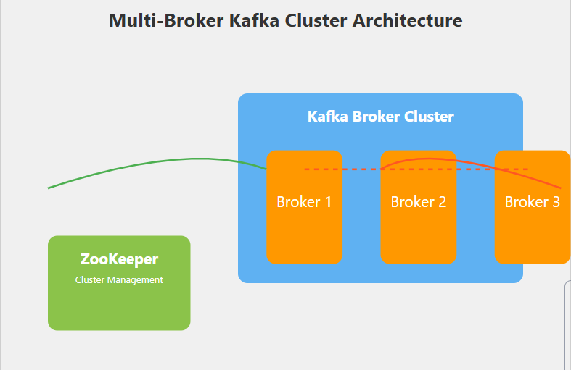

. Cluster Architecture

Architectural Components
- Multiple Broker Servers
  - Physical or virtual machines running Kafka broker instances
  - Each broker is an independent server in the cluster
  - Runs a single Kafka broker process

Cluster Composition
- Typical Production Setup
  - Minimum 3 brokers recommended
  - Maximum depends on system requirements
  - Odd number of brokers ensures better consensus

ZooKeeper Integration
- Centralized coordination service
- Manages cluster metadata
- Handles broker registration
- Performs leader election
- Maintains cluster state consistency

2. Configuration Components

a) Broker Configuration
- Broker ID
  - Unique identifier for each broker
  - Must be unique across the cluster
  - Used for partition leader election

# Example broker configuration
broker.id=1 # Unique for each broker
- Listener Configurations
  - Define network interfaces for broker communication
  - Support multiple communication protocols

listeners=PLAINTEXT://:9092,SSL://:9093
advertised.listeners=PLAINTEXT://broker1.example.com:9092
- Log Directory Settings
  - Specify locations for message storage
  - Support multiple log directories for performance

log.dirs=/var/kafka/logs1,/var/kafka/logs2

b) Cluster-wide Settings
- Authentication Mechanisms
  - SSL/TLS encryption
  - SASL authentication
  - Role-based access control
- Inter-broker Communication
  - Secure communication protocols
  - Network-level security configurations

security.inter.broker.protocol=SSL

c) ZooKeeper Integration Details
- Cluster Coordination
  - Service discovery
  - Configuration management
  - Distributed synchronization
- ZooKeeper Connection String
zookeeper.connect=zk1:2181,zk2:2181,zk3:2181/kafka

3. Replication and Partition Management

Partition Distribution
- Partition Allocation Strategy
  - Automatically distributed across brokers
  - Ensures even load distribution
  - Considers broker capacity and current load

Replication Mechanism
- Replication Factor
  - Defines number of data copies
  - Typical production value: 3
  - Provides fault tolerance
- Replication Process
  - One leader partition
  - Multiple follower partitions
Leader Partition: Handles all read/write operations
Follower Partitions: Replicate data from leader

Leader Election
- Automatic process when broker fails
- ZooKeeper manages election
- Ensures continuous availability

4. Communication and Coordination

Inter-Broker Communication
- Request Handling
  - Distributed request processing
  - Load balancing of client requests
  - Efficient metadata propagation

Metadata Synchronization
- Cluster State Maintenance
  - Real-time cluster configuration updates
  - Consistent view across all brokers
  - Automatic propagation of configuration changes

Benefits Explanation

1. High Availability
- Redundancy Mechanisms
  - Multiple broker copies of data
  - Automatic failover
  - Continuous operation during partial failures

2. Scalability
- Dynamic Cluster Expansion
  - Add brokers without downtime
  - Linear performance scaling
  - Flexible resource allocation

3. Fault Tolerance
- Failure Recovery
  - Automatic partition reassignment
  - No data loss during broker failures
  - Self-healing cluster architecture

4. Load Distribution
- Intelligent Partition Assignment
  - Even data distribution
  - Performance optimization
  - Resource utilization balancing

5. Performance Optimization
- Parallel Processing
  - Concurrent message handling
  - Reduced latency
  - Efficient resource utilization

- Describe the complete messaging flow in Apache Kafka from producer to consumer.

1. Producer-Side Processing
- Message Creation
  - Generate message content
  - Define topic destination
  - Select partition (optional)
- Serialization
  - Convert message to byte stream
  - Apply configured serializers
  - Supports custom serialization
- Partitioning
  - Determine message destination partition
  - Default: Hash-based partition selection
  - Custom partitioners possible

2. Broker-Side Processing
- Message Validation
  - Check message integrity
  - Validate against configuration
  - Apply security policies
- Persistence
  - Write to log segments
  - Commit to disk
  - Replicate across brokers
- Offset Assignment
  - Unique sequential offset
  - Enables exactly-once processing

3. Consumer-Side Processing
- Topic Subscription
  - Specify topics of interest
  - Join consumer group
  - Assign partitions
- Message Polling
  - Request messages from brokers
  - Specify offset starting point
  - Configure fetch parameters
- Message Processing
  - Deserialize message
  - Apply business logic
  - Commit offset upon successful processing

Key Characteristics

Reliability Mechanisms
- Acknowledgement configurations
- Retry strategies
- Exactly-once processing semantics

Performance Optimizations
- Batch processing
- Compression
- Parallel consumption

Example Code Snippet
// Producer
KafkaProducer<String, String> producer = new KafkaProducer<>(props);
ProducerRecord<String, String> record =
new ProducerRecord<>("users", "user-id", "user-data");
producer.send(record);

// Consumer
KafkaConsumer<String, String> consumer = new KafkaConsumer<>(props);
consumer.subscribe(Collections.singletonList("users"));
while (true) {
ConsumerRecords<String, String> records = consumer.poll(Duration.ofMillis(100));
for (ConsumerRecord<String, String> record : records) {
// Process each record
}
}

- Implement a Kafka Producer method with error handling and message serialization.
https://www.geeksforgeeks.org/exception-handling-in-apache-kafka/
- Explain the critical role of Zookeeper in a Kafka distributed system.
https://www.geeksforgeeks.org/what-is-apache-zookeeper/
- Discuss different partitioning strategies in Kafka and their impact on message processing.
https://www.decodingdevops.com/kafka-topic-partitioning-strategy-optimizing-performance-and-scalability/
- Describe how Kafka ensures fault tolerance and high availability in a distributed system.

